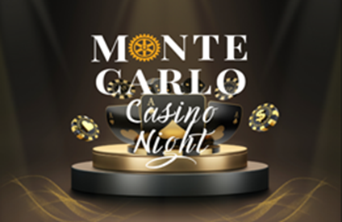
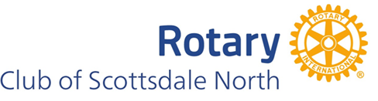
Thank you for being a sponsor for our Monte Carlo Casino Night fundraising event on April 20, 2024 benefiting the Scottsdale North Rotary Foundation and OCJ KIDS supporting Arizona’s foster kids. Your generous support will make an essential difference in many people's lives in our community.

2024 Sponsor Donor Form

Note: To digitally complete this form, please click on each shaded area to fill in your information. Your “TAB key will allow you to easily move from one shaded area to the next area in the form.

Donor Information:
Sponsor Name and Title:
Company:
Website Address
Phone: |  |  |  |  |  | Email:
Mailing Address:
Rotary Contact Name:

Your receipt will be sent to the email listed above.
Please check your preferred sponsor level:
High Roller $5,000 (Includes 8 tickets)
Blackjack $2,500 (Includes 6 tickets)
Jackpot $1,000 (Includes 4 tickets)
Table Sponsor $ 600 (Includes 2 tickets)
Sponsor Logo:
Please provide a high-resolution image of your logo. X

Check box if you would like our marketing team to capture your logo from your website

Note: To digitally insert pictures into this form, please click on the center image of the blue shaded box below and follow the instructions. Please use high resolution pictures.

Payment Methods:

Please scan QR code or click on this link to access the fundraiser event payment site.
https://www.givsum.com/opportunities/monte-carlo-casino-night-d09020b6c
If paying by check, please make checks payable to Scottsdale North Rotary Foundation

Scottsdale North Rotary Foundation is a 501(c)(3) tax deductible organization - Tax ID # 81-2892219
Mailing address: 8711 E. Pinnacle Peak Road, PMB 138, Scottsdale, AZ 85255
https://www.rotaryscottsdalenorth.org

